**DATA TYPES :**

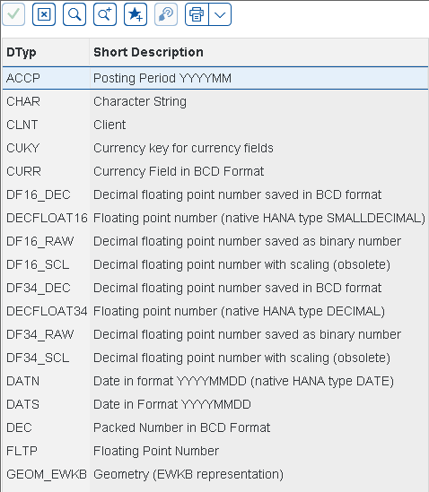

**DATA OBJECTS:**

A data object is a part of the repository whose content can be addressed and interpreted by the program. All data objects must be declared in the ABAP program and are not persistent, meaning that they only exist while the program is being executed. Before you can process persistent data (such as data from a database table or from a sequential file), you must read it into data objects first. Conversely, if you want to retain the contents of a data object beyond the end of the program, you must save it in a persistent form.

**TYPES OF DATA OBJECTS:**

1.Literals

2. Named Data Objects

3. System-Defined Data Objects

4. Interface Work Areas

**CREATION OF TABLES:**

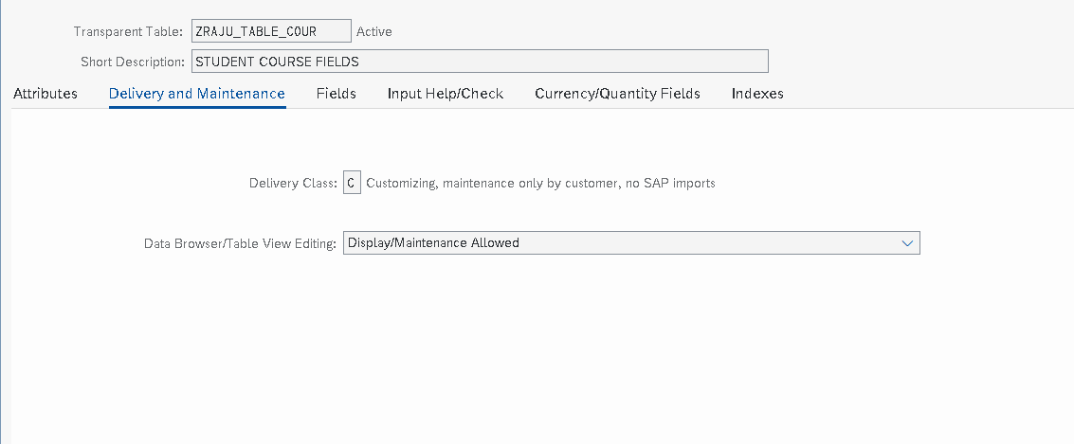

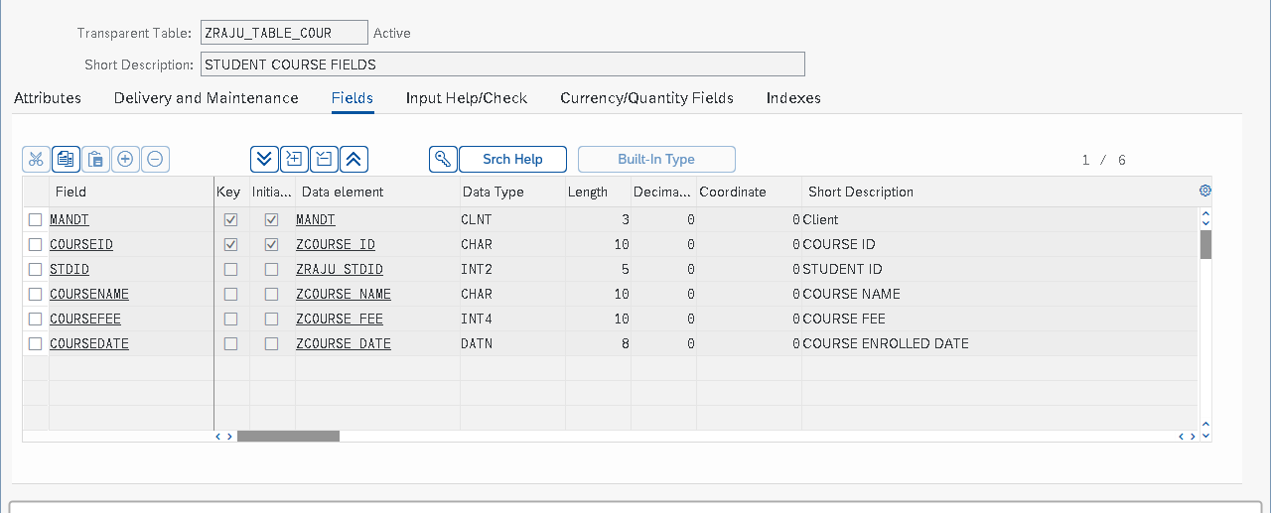

**GIVING INPUTS THROUGH TMG:**

**1.creation of TMG.**

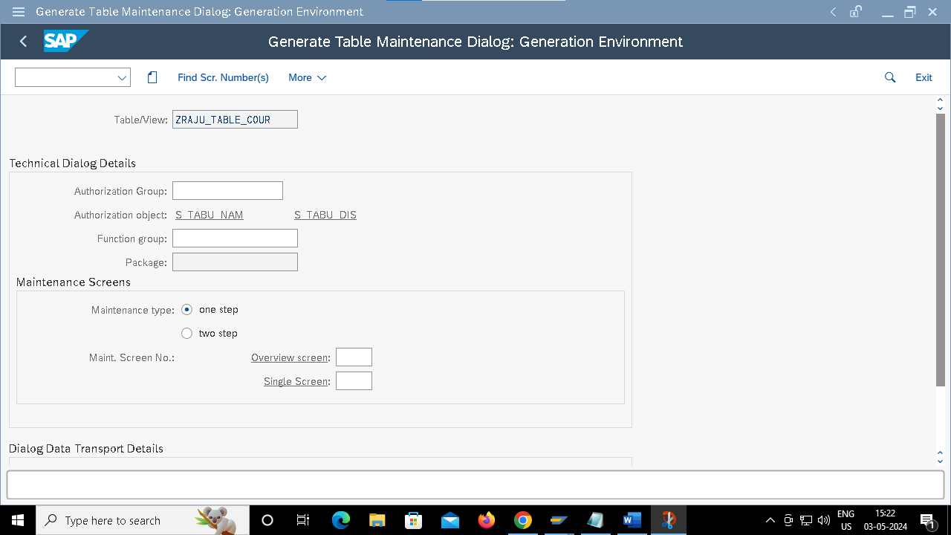

**FOREIGN KEY:**

